Company Backgrounder

About Us

Parallel Wireless is reimagining the wireless infrastructure market, enabling carriers, public safety, and enterprises to adopt a standards-based NFV and SDN-enabled architecture that dramatically reduces the cost and time-to-market of building, expanding, and maintaining cellular networks. The Parallel Wireless complete cloud-managed networking solution redefines the economics of wireless rollouts as it reduces complexity, promotes advanced interoperability for multi-vendor, multi-technology HetNets, allows real-time network orchestration, and enables new services. Parallel Wireless’ approach accelerates the transition to cloud networking for wireless networks as it extends existing investments and improves how to optimize and maintain the RAN/EPC.
This breakthrough technology is critical to deliver resilient coverage and capacity on demand, enable IoT, and provide optimized user experience while lowering the cost of video and multimedia distribution over cellular. Currently, the company is live or in trials with major leading operators on five continents. This is made possible by ease of deployment and auto-configuration and on-going optimization – the foundation that Parallel Wireless innovation is built on.
The Parallel Wireless team has experience building every component of the cellular network across 2G, 3G, and 4G. For the past three years, this team has been reimagining the architecture of the cellular RAN to make deploying and maintaining any G networks, including 5G HetNets, as easy and cost-effective as enterprise Wi-Fi networks.
Parallel Wireless’ innovation and excellence has been recognized with 25 industry awards since 2014. Parallel Wireless has also been named by Fierce Wireless to its “Fierce 15” list which highlights top emerging technology startups of great potential. For more information, please visit www.parallelwireless.com.
Product Offerings

Parallel Wireless products are designed to make carrier-grade RAN deployments as easy and cost-effective as Wi-Fi by eliminating RAN network complexity and reducing maintenance costs.
- HetNet Gateway (HNG) is the industry’s first carrier-grade, NFV/SDN-based, 3GPP compliant RAN orchestrator that can orchestrate any technology (3G, 4G, Wi-Fi) and any vendor RAN. HNG logically sits between the RAN and core and virtualizes RAN on any COTS hardware while making RAN self-configuring, self-optimizing, and self-healing. Currently released HetNet Gateway supports 3G gateway, 4G gateway, Wi-Fi gateway, multi-technology SON, MEC, elastic scheduling capabilities. Moreover, these functions interwork with one another, instead of operating in individual silos, to deliver agility and flexibility across the network. HNG makes any RAN easy to deploy, scale, & maintain while delivering QoS across any licensed & unlicensed technologies, in rural & urban locations, enterprise, public safety, even on the cell edge. This solution uses standard backhaul and orchestrates a resilient mesh across the various backhaul elements. As a result, higher device density can be delivered and networks can be built or expanded at much lower cost, making cellular deployments for any market as easy and as cost-effective as enterprise Wi-Fi.
- CONVERGED WIRELESS SYSTEM (CWS) is a software-defined, multi-mode, multi-band base station. It leverages the latest silicon to support 3G and 4G and integrates flexible backhaul (including wireless SDN mesh) all in the same form factor to deliver instant, reliable, and cost-effective coverage anywhere. The nodes are self-configured and self-managed via HetNet Gateway to enable easy and cost-effective deployments. Self-orchestration enabled by HNG provides hands-free maintenance of CWS’ with SON-based interference mitigation for access and backhaul, SON-controlled dynamic RF power adjustment, and software-defined radio (SDR) capabilities that future-proof CWS’ for additional bands or band reconfigurations. CWS provides resilient coverage indoors and out with flexible deployment options and lowers overall TCO.
- UNI-MANAGE is a software based Element Management System (EMS) for the CWS and HNG components and provides a web based user interface (UI) to configure, manage, and monitor the network elements.

Network Solution Overview
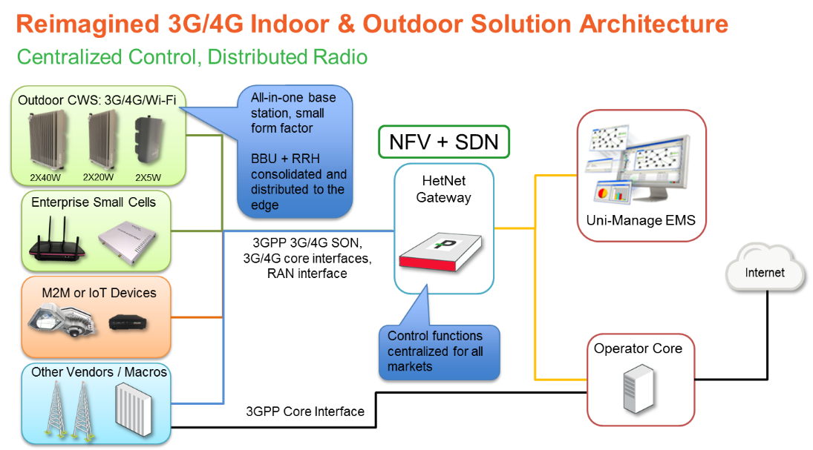

Leadership Team

Steve Papa, Founder, CEO, and Chairman. Steve has been reimagining the technology landscape for the over 20 years. As founder and CEO of Endeca, he reimagined the database to support faceted information ultimately leading to Oracle acquiring the company as its 6th largest acquisition ever when announced (reported at $1.1 billion). He was part of the team creating Akamai that reimagined global Internet content distribution – now carrying peaks of 15 terabits/s of web traffic on any given day – and led the team at Inktomi that reimagined the network cache to create carrier class caching. Earlier he worked with AT&T Teradata where enterprise computing was reimagined with the first use of Intel processors for enterprise servers. He has a BS from Princeton University and MBA from Harvard Business School.
Rajesh Mishra, Founder, President and CTO. Rajesh co-founded Parallel Wireless after 21+ years of reimagining the wireless, wireline, and cable industries. He led the development of next-gen VoLTE and 3G/4G Femtocell convergence servers at Tatara, led transformation of first commercial softswitch into a Wireless MSC product at Bell Labs/Lucent, reimagined cable industry leading IMS servers at Cedarpoint, and led commercial mobile ad hoc networks (MANETS) development at Powerwave Cognition. He has 25 US and international patents pending and issued. He holds a BS in Computer Science from IIT.
Kaitki Agarwal, Founder and VP of Development. Kaitki co-founded Parallel Wireless after 20+ years of leading and managing worldwide product development teams who reimagined the Packet Core. Kaitki led strategic Multimedia/VoLTE development at Starent/Cisco, was responsible for SS7 & SIP Signaling at Cedarpoint, Wireless MSC at Lucent/Bellabs and was involved in reimagining Base Station Controller (BSC) for wireless network at Tellabs. Kaitki has 20 US patents pending and issued. Kaitki holds MBA from Babson College and a BS in Computer Science from IIT.
Sridhar Donepudi, Founder and VP, Systems. Sridhar co-founded Parallel Wireless after 20+ years as a proven technology leader with a focus on reimagining traffic/policy management, base stations, Class 5 Switching, IMS Core, Wireless MSC and Telephony Application Server. As the Sr. Principal Architect of next-gen products, Sridhar reimagined the design and development of Cedar Point/Genband 3GPP traffic and policy management solution. He was a founding member of several successful startups such as Cedar Point (acquired by Genband) where he was Technical Director of Call Processing, Excel Switching/Lucent (Technical Lead) where he led the design of Lucent soft switch, and Tellabs Wireless where he led design of PCS base stations. He has 15 US patents pending and issued. He holds an M.Tech in Applied Electronics from CIT and B.E in Electronics Engineering.
Simon Mellor, GM, EMEA. Simon Mellor has over 30 years of experience as a telecom and defense industry executive. Simon was the founder and CEO of Axis Network Technology and reimagined the remote radio head with a next-generation re-configurable digital radio platforms company. As a result of the company’s technology and significant market share, it was acquired by a leading Korean manufacturer, AceAxis, and its products have been deployed in numerous cellular networks around the world. Prior to AceAxis, Mr. Mellor led technology strategy at Airtech as Chief Technology Officer, where he reimagined base station and coverage enhancement equipment. While serving as a head of Global Business Development and then for European Sales for REMEC, he achieved significant growth in multiple OEM accounts. Simon holds an MSc, Microwave and Modern Optics from U.of London, BSc, Electronic Physics from Royal Holloway, University of London and MBA from The Open University.

Offices

Parallel Wireless’ worldwide headquarters are located in Nashua New Hampshire, with Sales Offices in Asia and EMEA, and a Research Center in India.

Headquarters
Parallel Wireless, Inc.
1 Tara Blvd, Suite 404
Nashua, NH 03062, USA Google map
Phone: +1-603-589-9937

Parallel Wireless India
B/101-104, Pune IT Park,
Bhau Patil Road, Bopodi,
Pune-411 020 Maharastra, India Google map
Phone: +91-20-6605-1600

Office nos. 212 & 603, 1st Floor, The Address, Survey No. 17/1, Kadubeesanahalli, Varthur Hobli, Outer Ring Road, Marathalli, Bangalore 560 103

Global Sales
Parallel Wireless APAC
E-mail: APAC@parallelwireless.com

Parallel Wireless EMEA
E-mail: EMEA@parallelwireless.com

Boilerplate
Parallel Wireless is reimagining the wireless infrastructure market, enabling carriers to deploy cellular networks as easy and as cost-effective as enterprise Wi-Fi whether for rural, enterprise, public safety, M2M, Smart Cities, or dense urban. Currently, the company is live or in trials with major leading operators on five continents. Parallel Wireless’ innovation and excellence has been recognized with 25 industry awards and a nomination to the “Fierce 15” top emerging technology startups list. Connect with Parallel Wireless on LinkedIn and Twitter.

